**Experimental Results**

**Participant 1:** Tan

**Affect Trend**

This is for morning results only. End-of-day results still need to be processed, but are very similar to this.

X-axis indicates time stamp. First graph shows the user’s valence over time. Second graph shows the user’s arousal over time. In these graphs, blue dots indicate user’s measured body language over time, and orange dots indicate user’s measured vocal intonation. The black line indicate the multi-modal fusion, and the grey line indicates the user’s overall average valence/arousal. The third graph shows the robot’s emotion and emotional output. This graph also indicate interaction is during time-stamp from 1:26 to 8:04. Thus, one can ignore measured valence and arousal outside these timestamps.

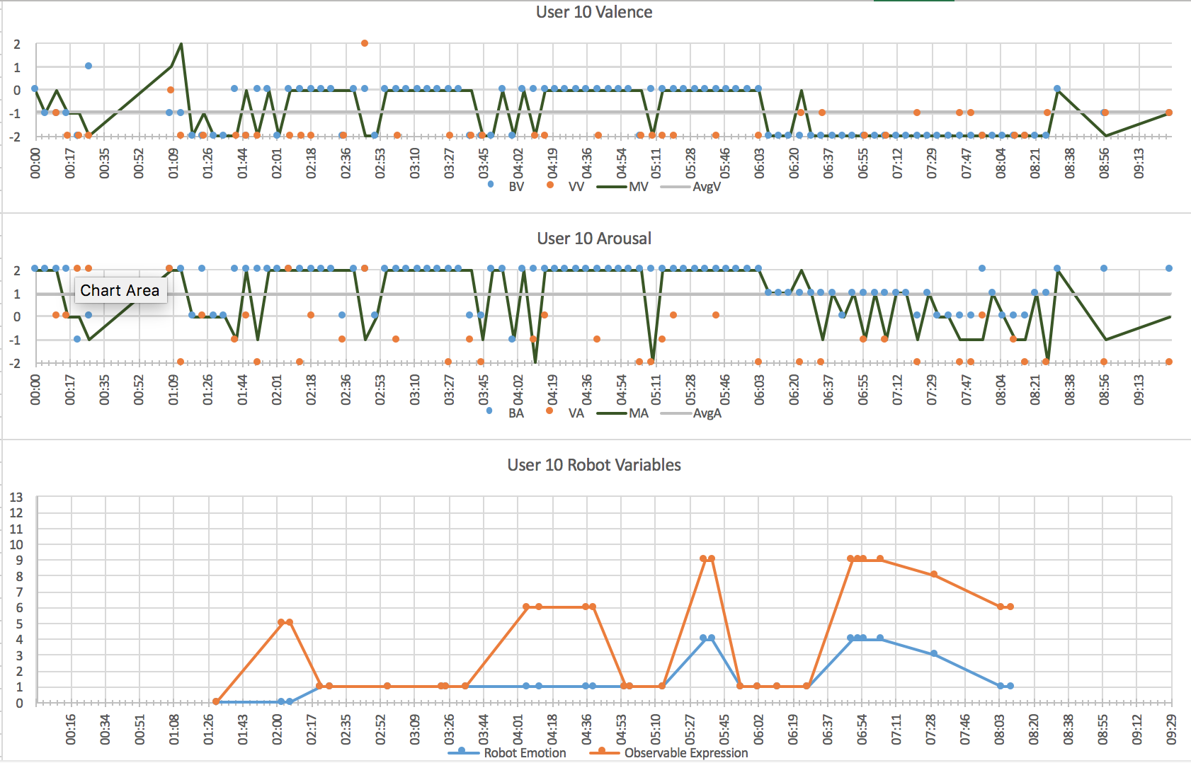

The legend for the third graph are as follows:

|  |  |  |  |  |  |  |
| --- | --- | --- | --- | --- | --- | --- |
| **Emotions** | 0 | happy |  | **Observable Expressions** | 0 | happy |
|  | 1 | hope |  |  | 1 | hope |
|  | 2 | sad |  |  | 2 | sad |
|  | 3 | fear |  |  | 3 | fear |
|  | 4 | anger |  |  | 4 | anger |
|  | 5 | scared 1 |  |  | 5 | happy2 |
|  | 6 | scared 2 |  |  | 6 | hope2 |
|  | 7 | scared 3 |  |  | 7 | sad2 |
|  |  |  |  |  | 8 | fear2 |
|  |  |  |  |  | 9 | anger2 |
|  |  |  |  |  | 10 | scared 1 |
|  |  |  |  |  | 11 | scared 2 |
|  |  |  |  |  | 12 | scared 3 |

**Finite State**

The following table shows the state of the robot over time, and it’s emotional output for each state. The time stamps correspond the the sensed affect.

|  |  |  |  |  |
| --- | --- | --- | --- | --- |
| **Time** | **FSM State** | **FSM State Name** | **Robot Emotion** | **Observable Expression** |
| 01:30 | 1 | morningIntro | 0 | 0 |
| 02:03 | 2 | morningGood | 0 | 5 |
| 02:07 | 4 | askWeather | 0 | 5 |
| 02:22 | 9 | askWeatherBad | 1 | 1 |
| 02:27 | 10 | askWeatherBadParis | 1 | 1 |
| 02:56 | 12 | askWeatherBadDiffHome | 1 | 1 |
| 03:23 | 13 | askWeatherBadDiffHomeYesTake | 1 | 1 |
| 03:25 | 15 | checkEdgeSafety1 | 1 | 1 |
| 03:35 | 16 | askBreakfast | 1 | 1 |
| 04:06 | 17 | askBreakfastAte | 1 | 6 |
| 04:12 | 22 | askDietPoultry | 1 | 6 |
| 04:36 | 23 | askDietPoultryYesEat | 1 | 6 |
| 04:39 | 18 | askDietGluten | 1 | 6 |
| 04:55 | 19 | askDietGlutenYesEat | 1 | 1 |
| 04:58 | 25 | meal2DecideLunch | 1 | 1 |
| 05:14 | 26 | mealFeedbackLunch | 1 | 1 |
| 05:35 | 27 | meal2FeedbackYesDelici | 4 | 9 |
| 05:39 | 30 | askDietFish | 4 | 9 |
| 05:53 | 31 | askDietFishYesEat | 1 | 1 |
| 06:02 | 33 | checkEdgeSafety2 | 1 | 1 |
| 06:12 | 34 | meal3DecideDinner | 1 | 1 |
| 06:27 | 35 | meal3FeedbackDinner | 1 | 1 |
| 06:49 | 36 | meal3FeedbackYesGood | 4 | 9 |
| 06:52 | 39 | exerciseDecide | 4 | 9 |
| 06:55 | 41 | exerciseWeatherBad | 4 | 9 |
| 07:04 | 42 | exerciseFeedback | 4 | 9 |
| 07:31 | 42 | exerciseFeedback | 3 | 8 |
| 08:04 | 43 | exerciseFeedbackGood | 1 | 6 |
| 08:09 | 46 | morningEnd | 1 | 6 |

**Participant Body Language:**

As indicated from the affect trend, the participant’s body language and voice was overall negative for valence. Body language was overall very static and inexpansive as shown in the next few figures. The voice was also slow and low tempo. Arousal may fluctuate to a positive number sometimes because it classifies the user as fear or disgust due to closing of arms and some backward motion.

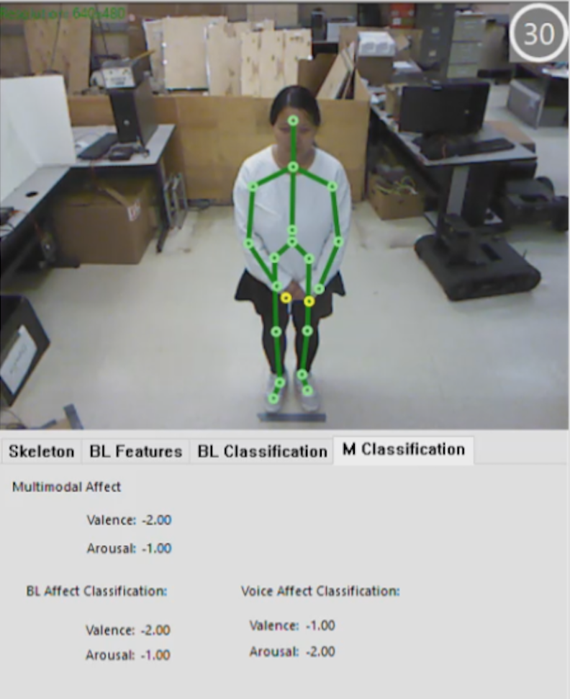

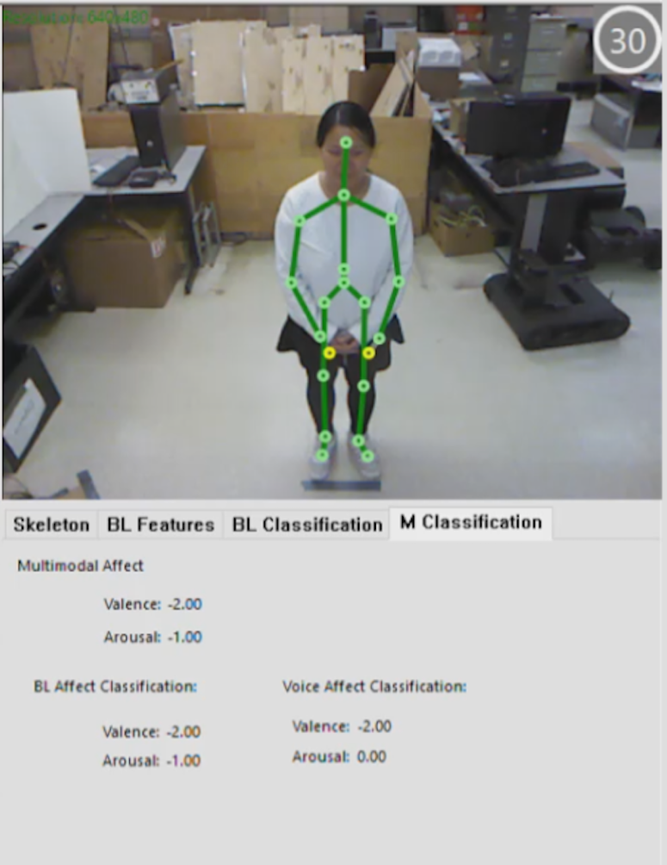

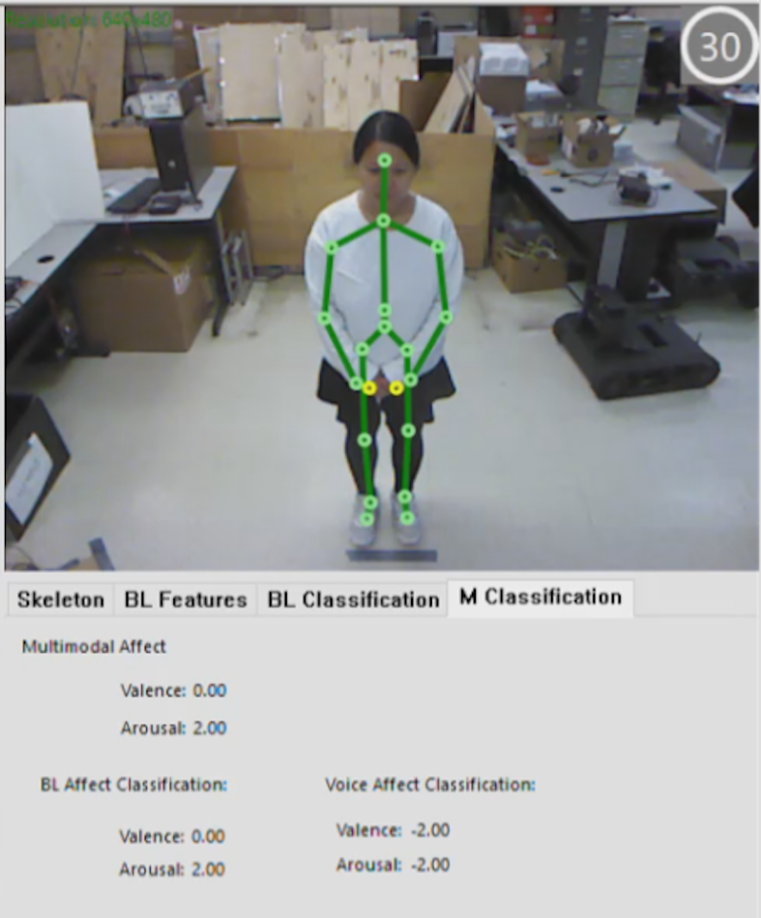

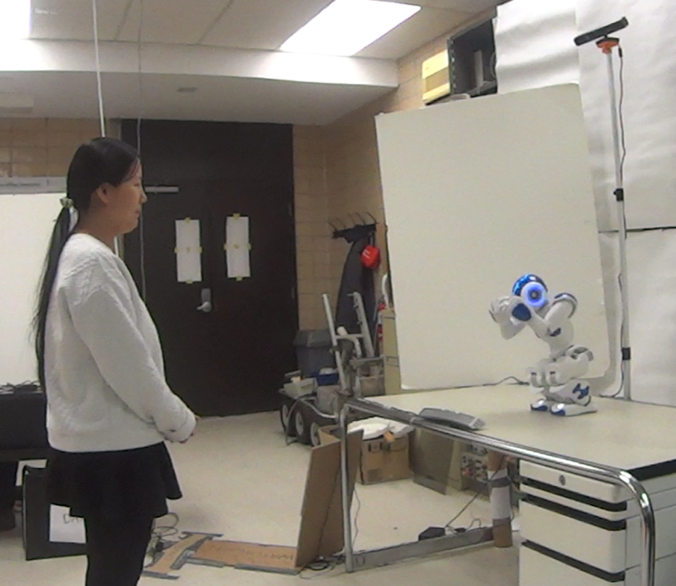

**Participant Response:**

